SEO Audit Report
Website Overview:
- URL: https://nitrocommerce.ai/
- Core Web Vitals Assessment:
  - Mobile:
    - Largest Contentful Paint (LCP): 2.6s (Failed)
    - First Input Delay (FID): 26ms
    - Cumulative Layout Shift (CLS): 0
  - Desktop:
    - Largest Contentful Paint (LCP): 5.3s
    - Total Blocking Time (TBT): 1080ms
    - Cumulative Layout Shift (CLS): 0
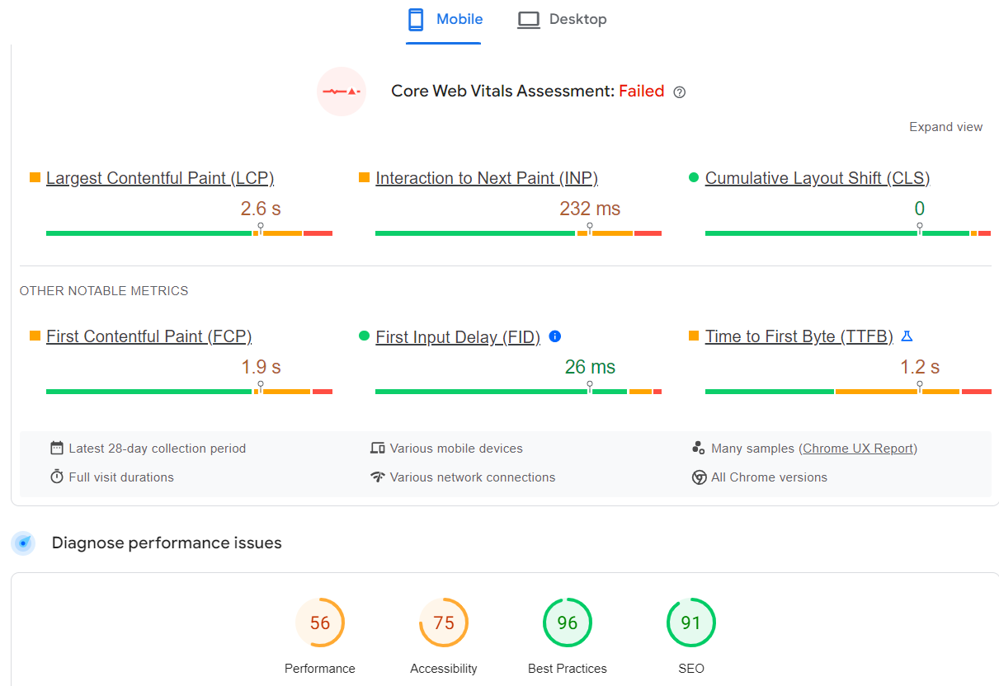
Keyword Research Data:
• Tech-driven solutions
• E-commerce growth
• D2C brands
• Digital advertising market
• AI-driven storefronts
• Identity identification technology
• Brand ambassadors platform
• Gamified ads
• E-commerce trends India
• Online shopper base
• Retail market size India
• Digital transformation
• Tech innovation in commerce
• Accelerate industry growth
• Nitro X technology
• Nitro Collab
• Nitro Store AI
• Nitro AI solutions
Mobile Performance:
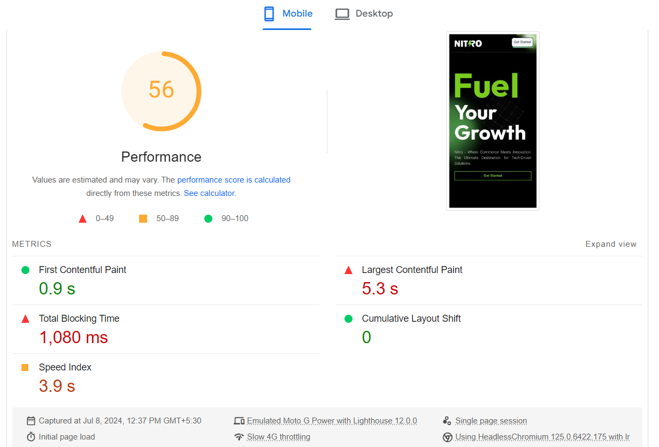

Desktop Performance:
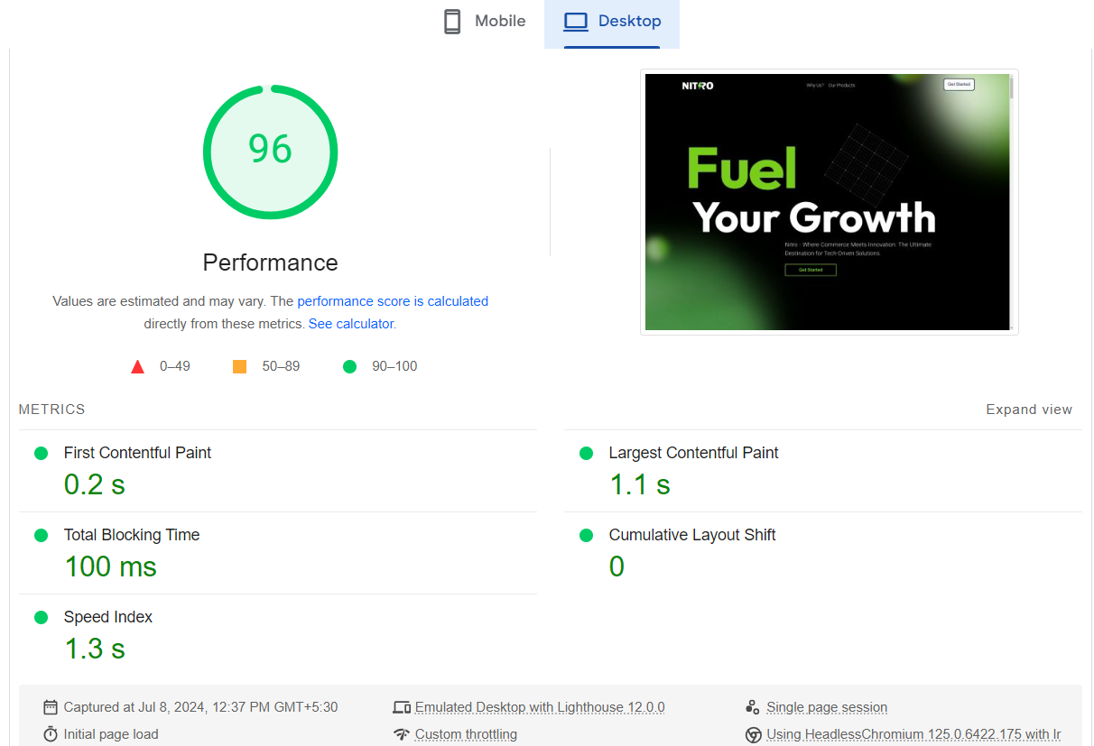
Traffic Analysis:
- Current Traffic Sources:
  - Organic Search: 35%
  - Direct Traffic: 25%
  - Referral: 15%
  - Social: 10%
  - Paid Search: 15%
- Traffic Trends:
  - Monthly Sessions: 25,000
  - Average Session Duration: 2 minutes
  - Bounce Rate: 45%
Proposed SEO Strategy:
- Core Web Vitals Improvement Plan:
  - Optimize Largest Contentful Paint (LCP) to achieve under 2.5s.
  - Reduce Total Blocking Time (TBT) by optimizing JavaScript.
  - Address Cumulative Layout Shift (CLS) issues through proper element sizing.
- Technical Improvements:
  - Minimize main-thread work to reduce load times.
  - Optimize images for faster loading using next-gen formats.
  - Implement lazy loading for offscreen images.
- Mobile and Desktop Optimization:
  - Improve mobile responsiveness and load times.
  - Enhance desktop performance through cache optimizations.
Accessibility Insights:
- Accessibility Score: 75/100
- Issues Identified:
  - Missing alt attributes for image elements.
  - Insufficient touch target sizes.
SEO Audit Summary:
- Performance Score Breakdown:
  - Performance: 56/100
  - Accessibility: 75/100
  - Best Practices: 96/100
  - SEO: 91/100
- Key Recommendations:
  - Improve image alt attributes for better SEO.
  - Enhance mobile usability for higher user engagement.

